Jeremy Scheuerman

Lab 4 writeup

Dr. Wang

Compilation and linking



Menu

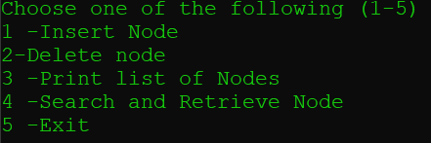

Insert

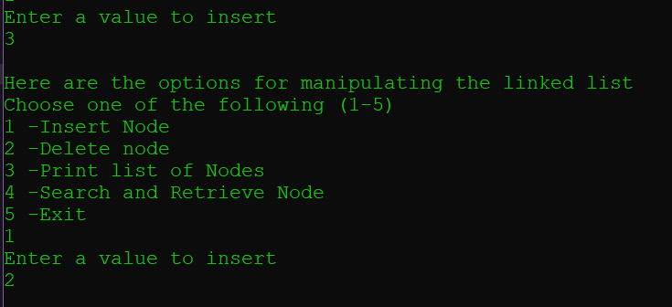

Print

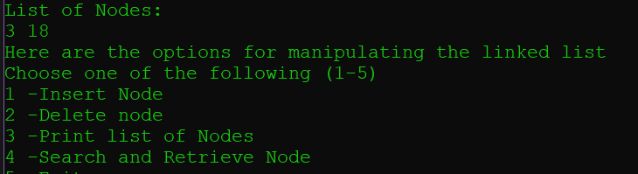

Delete

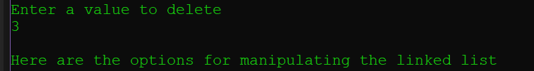

4

